Practical no 21
AIM: Develop an Android application that uses SMS functionality to send text messages by handling necessary permissions and using appropriate APIs.
activity_main.xml:
<?xml version="1.0" encoding="utf-8"?>
<LinearLayout xmlns:android="http://schemas.android.com/apk/res/android"
android:layout_width="match_parent"
android:layout_height="match_parent"
android:orientation="vertical"
android:padding="25dp">
<TextView
android:layout_width="match_parent"
android:layout_height="wrap_content"
android:text="SMS Application"
android:textSize="28sp"
android:textStyle="bold"
android:gravity="center"
android:layout_marginBottom="30dp" />
<EditText
android:id="@+id/phoneNumber"
android:layout_width="match_parent"
android:layout_height="wrap_content"
android:hint="Enter phone number"
android:inputType="phone"
android:padding="15dp" />
<EditText
android:id="@+id/message"
android:layout_width="match_parent"
android:layout_height="wrap_content"
android:hint="Enter message"
android:inputType="textMultiLine"
android:minLines="4"
android:gravity="top"
android:padding="15dp"
android:layout_marginTop="15dp" />
<Button
android:id="@+id/sendButton"
android:layout_width="match_parent"
android:layout_height="wrap_content"
android:text="SEND SMS"
android:layout_marginTop="25dp" />
</LinearLayout>

MainActivity.java
package com.example.pr21a;
import android.Manifest;
import android.content.pm.PackageManager;
import android.os.Bundle;
import android.telephony.SmsManager;
import android.widget.Button;
import android.widget.EditText;
import android.widget.Toast;
import androidx.annotation.NonNull;
import androidx.appcompat.app.AppCompatActivity;
import androidx.core.app.ActivityCompat;
import androidx.core.content.ContextCompat;
public class MainActivity extends AppCompatActivity {
EditText phoneNumber, message;
Button sendButton;
private static final int SMS_PERMISSION_CODE = 100;
@Override
protected void onCreate(Bundle savedInstanceState) {
super.onCreate(savedInstanceState);
setContentView(R.layout.activity_main);
phoneNumber = findViewById(R.id.phoneNumber);
message = findViewById(R.id.message);
sendButton = findViewById(R.id.sendButton);
sendButton.setOnClickListener(v -> {
String number = phoneNumber.getText().toString().trim();
String text = message.getText().toString().trim();
if (number.isEmpty()) {
phoneNumber.setError("Enter phone number");
return;
}
if (text.isEmpty()) {
message.setError("Enter message");
return;
}
if (ContextCompat.checkSelfPermission(
MainActivity.this,
Manifest.permission.SEND_SMS
) != PackageManager.PERMISSION_GRANTED) {
ActivityCompat.requestPermissions(
MainActivity.this,
new String[]{Manifest.permission.SEND_SMS},
SMS_PERMISSION_CODE
);
} else {
sendSMS(number, text);
}
});
}
private void sendSMS(String number, String text) {
try {
SmsManager smsManager = SmsManager.getDefault();
smsManager.sendTextMessage(
number,
null,
text,
null,
null
);
Toast.makeText(
MainActivity.this,
"SMS Sent Successfully",
Toast.LENGTH_SHORT
).show();
} catch (Exception e) {
Toast.makeText(
MainActivity.this,
"SMS Sending Failed",
Toast.LENGTH_SHORT
).show();
}
}
@Override
public void onRequestPermissionsResult(
int requestCode,
@NonNull String[] permissions,
@NonNull int[] grantResults) {
super.onRequestPermissionsResult(
requestCode,
permissions,
grantResults
);
if (requestCode == SMS_PERMISSION_CODE) {
if (grantResults.length > 0 &&
grantResults[0] == PackageManager.PERMISSION_GRANTED) {
Toast.makeText(
MainActivity.this,
"SMS Permission Granted",
Toast.LENGTH_SHORT
).show();
} else {
Toast.makeText(
MainActivity.this,
"SMS Permission Denied",
Toast.LENGTH_SHORT
).show();
}
}
}
}

AndroidManifest.xml
<?xml version="1.0" encoding="utf-8"?>
<manifest xmlns:android="http://schemas.android.com/apk/res/android">
<uses-permission android:name="android.permission.SEND_SMS" />
<application
android:allowBackup="true"
android:label="SMS App"
android:supportsRtl="true"
android:theme="@style/Theme.AppCompat.Light.NoActionBar">
<activity
android:name=".MainActivity"
android:exported="true">
<intent-filter>
<action android:name="android.intent.action.MAIN" />
<category android:name="android.intent.category.LAUNCHER" />
</intent-filter>
</activity>
</application>
</manifest>

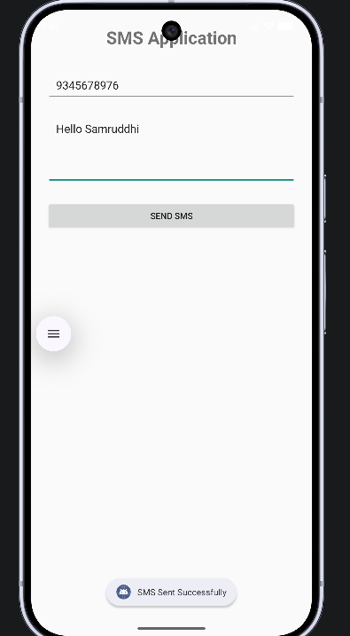
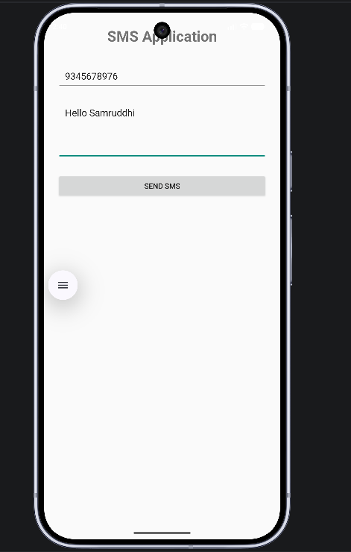
OUTPUT:

